A System and Method for a Neuromorphic-Orchestrated, Quantum-Secured 6G Communications Network

Abstract

A system and method for a self-managing, quantum-secured sixth-generation (6G) communications network is disclosed. The system comprises a tri-layered architecture featuring a 6G Transport Layer for high-throughput data transmission, a Quantum Security Layer (QSL) for providing information-theoretic security, and a Neuromorphic Cognitive Orchestration Layer (NCOL) for autonomous network management. The QSL utilizes a hybrid of Post-Quantum Cryptography (PQC) and Quantum Key Distribution (QKD) to secure network communications against both classical and quantum threats. The NCOL, implemented via a distributed network of neuromorphic co-processors running Spiking Neural Networks (SNNs), provides real-time, low-latency, and energy-efficient control over both the transport and security layers. Key inventive steps include a method for neuromorphic management of QKD trusted relays, wherein the NCOL dynamically assesses relay trustworthiness to route quantum keys along the most secure paths, thereby mitigating critical vulnerabilities in prior art. The invention further includes a system for emergent intent-based networking, where the network self-organizes to fulfill high-level service objectives, and a method for predictive self-healing based on microsecond-level anomaly detection. A quantum-state-aware digital twin, managed by the NCOL, enables high-fidelity simulation and pre-validation of network optimizations, including the probabilistic behavior of the quantum layer, facilitating true network self-evolution.

Background of the Invention

Field of the Invention

This invention pertains to the field of telecommunications, specifically to the architecture, management, and security of next-generation wireless networks. It further relates to the integration of quantum communication protocols and neuromorphic computing systems for autonomous network orchestration, providing a resilient, intelligent, and secure infrastructure for future digital services.

Description of Related Art

The evolution of wireless communication has been characterized by generational leaps in capability, each enabling new paradigms of connectivity and application. The fifth generation (5G) of wireless technology delivered significant advancements through three primary service categories: enhanced Mobile Broadband (eMBB), Ultra-Reliable Low-Latency Communications (URLLC), and massive Machine-Type Communications (mMTC).¹ These capabilities have begun to power the Internet of Things (IoT), connected vehicles, and immersive media. However, the architectural underpinnings of 5G networks, while a substantial improvement over previous generations, face fundamental limitations in scalability, energy consumption, and management complexity as the world moves towards a true Internet of Everything (IoE), where trillions of devices are expected to be connected.²
Projections for the sixth generation (6G) of wireless technology, expected to be commercialized around 2030, envision a network that is not merely an incremental improvement but a transformative platform.⁴ Key performance indicators for 6G include peak data rates of up to 1 terabit per second (Tbps), user-experienced data rates of 1 gigabit per second (Gbps), air latency below 100 microseconds, and connection densities exceeding 10 million devices per square kilometer.² Achieving this vision requires the adoption of new technologies such as the use of Terahertz (THz) frequency bands, cell-free massive Multiple-Input Multiple-Output (MIMO) antenna systems, and Integrated Sensing and Communication (ISAC), where the network infrastructure simultaneously communicates and senses the physical environment.⁶ This leap in performance and functionality will create a network of unprecedented complexity, where traditional network management and orchestration (MANO) systems, even those augmented with conventional Artificial Intelligence (AI), will be insufficient.⁹ The 6G network is envisioned as an AI-native system, a "distributed neural network" that fuses the physical, biological, and cyber worlds.¹¹ This inherent complexity demands a new paradigm of autonomous, intelligent, and efficient control.
Concurrently with the development of 6G, the field of quantum computing is rapidly advancing, posing a catastrophic threat to the security infrastructure that underpins the entire digital economy. Current public-key cryptography systems, such as RSA and Elliptic Curve Cryptography (ECC), rely on the computational difficulty of mathematical problems like factoring large integers.¹² A sufficiently powerful quantum computer, running algorithms like Shor's algorithm, will be able to solve these problems in a trivial amount of time, rendering nearly all currently deployed secure communication protocols obsolete.¹³ This vulnerability is not a distant threat but an immediate one, due to the "harvest now, decrypt later" attack vector.¹⁴ Adversaries are actively intercepting and storing vast quantities of encrypted data today, with the intention of decrypting it once a cryptographically relevant quantum computer becomes available. This compromises the long-term security of sensitive government, financial, and personal data transmitted over current networks.¹⁷
In response to this quantum threat, two primary security solutions have emerged: Post-Quantum Cryptography (PQC) and Quantum Key Distribution (QKD). PQC involves the development of new classical cryptographic algorithms based on mathematical problems believed to be hard for both classical and quantum computers.¹² While PQC offers a software-based upgrade path, its long-term security is based on unproven computational assumptions. QKD, conversely, offers information-theoretic security based on the fundamental laws of quantum mechanics, such as the no-cloning theorem and the principle that measurement disturbs a quantum system.²⁰ QKD allows two parties to generate a shared secret key with the guarantee that any attempt by an eavesdropper to intercept the key will be detected. However, the practical deployment of QKD over wide-area networks is severely hampered by a critical architectural flaw: its reliance on "trusted relays" or "trusted nodes".¹⁹ Due to photon loss in optical fiber, QKD links are typically limited to distances of a few hundred kilometers.²³ To extend this range, intermediate nodes must receive the quantum signal, convert it to a classical key, and then retransmit it on a new quantum link. These trusted relays possess the full secret key and thus represent highly attractive targets for physical or cyber-attack. The compromise of a single trusted relay can invalidate the security of the entire communication chain, a vulnerability that significantly curtails the promise of QKD.¹⁹
To manage the complexity of 5G and future 6G networks, AI and Machine Learning (ML) have been widely adopted for tasks such as network optimization, traffic management, and predictive maintenance.⁶ Existing patents, including those held by the assignee, describe systems for AI-driven network reconciliation and security threat detection.²⁷ However, these AI systems are predominantly based on conventional von Neumann computing architectures, such as Graphics Processing Units (GPUs) and Tensor Processing Units (TPUs). While powerful for offline training of large models, these architectures are ill-suited for the real-time, distributed, and energy-constrained demands of 6G network control. They exhibit high energy consumption, introduce significant latency in the decision-making loop, and operate on a reactive or slow predictive cycle based on large historical datasets.³⁰ This makes them incapable of responding to network dynamics at the microsecond timescale required for 6G URLLC services or detecting subtle, real-time anomalies indicative of sophisticated security breaches.
The prior art thus presents a set of profound, interdependent challenges. The escalating complexity of 6G networks demands a more powerful form of autonomous management. The looming quantum threat necessitates a new security paradigm, yet the most promising solution, QKD, contains a fundamental vulnerability. The conventional AI tools used to manage network complexity are too slow, power-hungry, and reactive to effectively control a 6G system or secure a quantum network in real time. What is needed, and what is absent from the prior art, is a unified architecture that holistically solves these interconnected problems—a system that is simultaneously ultra-fast, ultra-secure, and ultra-intelligent by design.

Metric | Traditional Management (Manual/Scripted) | Conventional AI-Driven (e.g., 5G SON with ML) | Proposed Neuromorphic Orchestration
Decision Latency | Hours to Days | Milliseconds to Seconds ³⁰ | Microseconds ³³
Energy Consumption | N/A (Human OPEX) | High (e.g., 10-100+ Watts per GPU) ³² | Ultra-Low (e.g., <1 Watt per NPU) ³²
Adaptability to Novel Events | Low (Requires manual reprogramming) | Medium (Requires model retraining on new data) | High (Real-time learning via synaptic plasticity) ³⁴
Security Response Time | Slow (Reactive to alerts) | Slow (Based on historical traffic analysis) | Real-Time (Event-driven anomaly detection) ³⁵
Scalability of Control | Poor (Limited by human operators) | Moderate (Bottlenecked by centralized processing) | High (Distributed, parallel, asynchronous processing) ³⁷
Quantum Security Vulnerability | Complete (Relies on classical crypto) | Complete (Relies on classical crypto) | Mitigated (Manages QKD & PQC layers)
QKD Relay Vulnerability | N/A | N/A | Addressed (Dynamic trust scoring & routing)
Table 1: Comparison of Network Management Paradigms

Summary of the Invention

The present invention provides a system and method for a neuromorphic-orchestrated, quantum-secured 6G communications network that overcomes the aforementioned limitations of the prior art. The invention introduces a holistic, tri-layered architecture that natively integrates an ultra-fast 6G Transport Layer, an ultra-secure Quantum Security Layer (QSL), and an ultra-intelligent Neuromorphic Cognitive Orchestration Layer (NCOL).
The NCOL serves as the cognitive core of the network, implemented as a distributed system of brain-inspired neuromorphic processors. Unlike conventional AI systems, the NCOL operates on the principles of Spiking Neural Networks (SNNs), enabling event-driven, asynchronous, and massively parallel processing. This results in decision-making and control loops that operate at microsecond latencies with orders-of-magnitude lower power consumption, providing the real-time intelligence necessary to manage the complexity of the 6G Transport Layer.
The QSL provides provable, long-term security against quantum adversaries through a hybrid approach. It utilizes Post-Quantum Cryptography (PQC) for robust authentication and control-plane security, while leveraging Quantum Key Distribution (QKD) over the assignee's extensive fiber infrastructure to generate information-theoretically secure keys for encrypting high-value user data.
A primary object of the invention is to solve the critical "trusted relay" vulnerability inherent in prior art QKD networks. This is achieved through a novel method wherein the NCOL continuously monitors the classical and quantum operational parameters of all QKD relays. Using its real-time pattern recognition capabilities, the NCOL assigns a dynamic "Trust Score" to each relay and intelligently routes quantum key generation requests along paths of highest aggregate trust, effectively creating a self-healing security fabric that can preemptively isolate potentially compromised nodes.
Another object of the invention is to introduce a new paradigm of network management, termed Emergent Intent-Based Networking. High-level business or service intents are translated into reward functions for the distributed SNNs of the NCOL. The network then self-organizes its resources and configuration, allowing the optimal operational state to emerge from the collective behavior of the neuromorphic agents, rather than being dictated by rigid, pre-programmed policies. This enables unprecedented adaptability to novel conditions and service requirements.
A further object of the invention is to provide a system for real-time predictive self-healing. By processing high-dimensional data streams from the 6G layer's integrated sensing capabilities, the NCOL's SNNs can detect subtle spatio-temporal precursors to hardware failures or performance degradation, triggering proactive mitigation measures before any service impact is experienced by the user.
Finally, an object of the invention is to introduce a Quantum-State-Aware Digital Twin. This is a high-fidelity simulation of the entire network, managed by the NCOL, which models not only the classical state of the transport layer but also the probabilistic quantum states of the QSL. This allows the NCOL to perform "future shot" simulations to pre-validate complex optimization and security strategies without risk to the live network, enabling a continuous cycle of self-evolution and improvement. The invention provides a clear path to commercialization through new premium service offerings, including Quantum-Security-as-a-Service (QSaaS) and Neuromorphic-Orchestration-as-a-Service (NOaaS).

Brief Description of the Drawings

The invention will be more fully understood from the following detailed description taken in conjunction with the accompanying drawings, in which:
FIG. 1 is a schematic block diagram illustrating the high-level tri-layered system architecture of the neuromorphic-orchestrated, quantum-secured 6G communications network.
FIG. 2 is a detailed schematic diagram of the Quantum Security Layer, illustrating the interconnection of QKD links, trusted relays, and next-generation quantum repeaters within the network infrastructure.
FIG. 3 is a detailed schematic diagram of the Neuromorphic Cognitive Orchestration Layer, illustrating the distributed placement of neuromorphic co-processors (NPUs) at edge and core network nodes and the logical structure of the Spiking Neural Network (SNN) models they execute.
FIG. 4 is a process flowchart illustrating the steps of the Neuromorphic-Managed Trusted Relay System, including data ingestion, anomaly detection, dynamic trust scoring, and intelligent key routing.
FIG. 5 is a process flowchart illustrating the steps of Emergent Intent-Based Networking, including intent translation into reward functions, network self-organization through synaptic plasticity, and the emergence of an optimal network state.
FIG. 6 is a conceptual diagram of the Quantum-State-Aware Digital Twin, illustrating its hybrid classical-quantum modeling approach and its interaction with the NCOL for "future shot" simulations and pre-validation of network strategies.

Detailed Description of the Invention

The present invention provides a comprehensive architecture for a next-generation communications network that is fundamentally autonomous, secure, and efficient. The system is designed to meet and exceed the projected demands of the 6G era by synergistically combining advances in wireless communication, quantum physics, and neuromorphic computing.

I. System Architecture: The Tri-Layered Cognitive Network

Referring to FIG. 1, the system architecture 100 is logically and functionally partitioned into three distinct yet deeply integrated layers: a 6G Transport Layer 110, a Quantum Security Layer (QSL) 120, and a Neuromorphic Cognitive Orchestration Layer (NCOL) 130. This layered approach allows for separation of concerns while enabling powerful cross-layer optimization and control facilitated by the NCOL 130.
The 6G Transport Layer 110 constitutes the physical infrastructure responsible for data transmission and sensing. This layer embodies the technological advancements anticipated for 6G networks.⁸ It comprises a Radio Access Network (RAN) featuring cell-free massive MIMO antenna arrays and operating in frequency bands up to and including the Terahertz (THz) spectrum to achieve multi-terabit-per-second data rates.² A core component of this layer is Integrated Sensing and Communication (ISAC), wherein network elements such as base stations and user equipment (UE) not only transmit and receive data but also actively sense the physical environment by analyzing radio wave reflections.⁷ This provides a rich, real-time stream of contextual data about the network's operating environment. The transport layer is further supported by a high-capacity optical fiber backhaul and a cloud-native, service-based core network architecture that is disaggregated and virtualized, running on commodity hardware from the network core to the far edge.⁷ This layer serves as the conduit for all user plane data, control plane signaling, and the raw sensory data ingested by the NCOL 130.

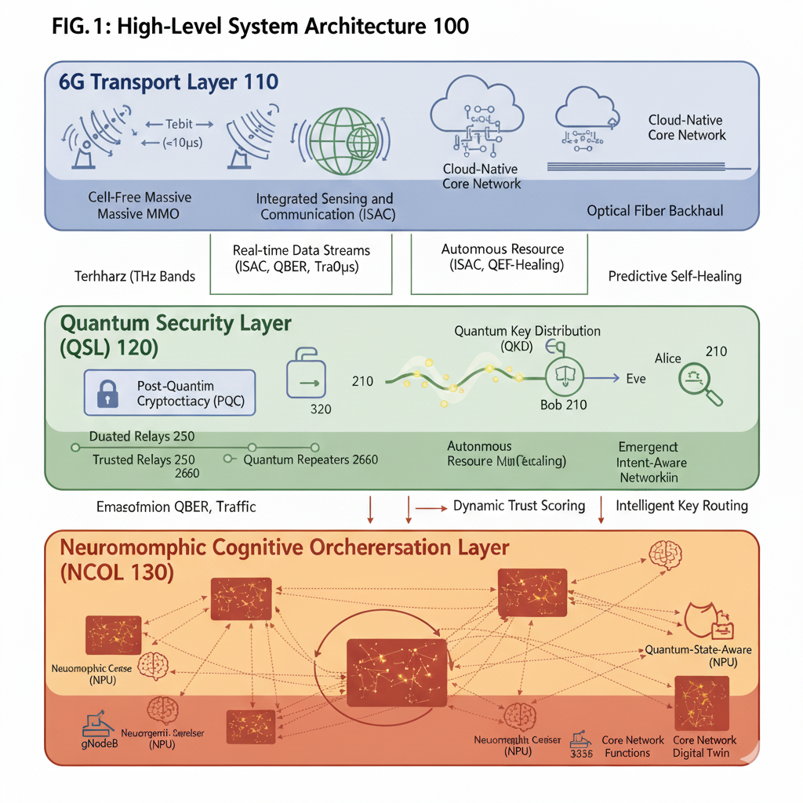
The Quantum Security Layer (QSL) 120 is an overlay network dedicated to providing robust, future-proof cryptographic services. It operates in parallel with the 6G Transport Layer 110, generating and distributing secure keys that are used to encrypt traffic flowing through the transport layer. The QSL 120 is implemented primarily over the assignee's existing and future-deployed optical fiber infrastructure, which is a prerequisite for practical quantum communication.⁴⁰ The QSL 120 is not a monolithic security solution but a hybrid framework, as will be detailed in Section II. Its primary function is to secure the network against attacks from both classical supercomputers and future fault-tolerant quantum computers, addressing the critical "harvest now, decrypt later" threat.¹⁴
The Neuromorphic Cognitive Orchestration Layer (NCOL) 130 is the intelligent control plane and the central nervous system of the entire architecture. It is a distributed intelligence system, physically realized by deploying specialized neuromorphic co-processors (NPUs) at strategic points throughout the network infrastructure, including base stations, edge data centers, and core network nodes.⁴² These NPUs are designed to execute Spiking Neural Networks (SNNs), a class of brain-inspired AI models that operate asynchronously and in an event-driven manner.³⁴ This architecture allows the NCOL 130 to monitor the state of both the 6G Transport Layer 110 and the QSL 120 with microsecond-level latency and extremely low power consumption.³⁰ It receives high-dimensional, real-time data streams—including traffic statistics, ISAC environmental data, and quantum channel state information—and uses this data to perform autonomous orchestration, predictive maintenance, and dynamic security management, as detailed in subsequent sections. The NCOL 130 replaces the slow, energy-intensive, and reactive control loops of conventional AI-managed networks with a proactive, adaptive, and highly efficient cognitive engine.

II. The Quantum Security Layer (QSL)

The QSL 120 is designed to provide end-to-end, long-term security for all communications within the network. It achieves this through a sophisticated hybrid framework that combines the strengths of multiple quantum-resistant technologies, ensuring both immediate and future protection.

Hybrid Security Framework

The security of the QSL 120 is founded on a two-pronged approach:
- Post-Quantum Cryptography (PQC): The system utilizes PQC algorithms, such as those standardized by the National Institute of Standards and Technology (NIST), for critical functions like digital signatures, authentication, and initial key establishment.¹⁴ These are classical algorithms designed to run on conventional hardware but are based on mathematical problems (e.g., lattice-based, code-based, or hash-based problems) that are believed to be intractable for both classical and quantum computers.¹² PQC provides a crucial baseline of security, enabling a secure boot-strapping process for network elements and securing control plane communications. It offers a practical, software-based path to quantum readiness that can be deployed across the entire network, including on resource-constrained IoT devices where implementing QKD is not feasible.⁴⁴
- Quantum Key Distribution (QKD): For securing high-value user plane data, particularly for services demanding the highest level of long-term confidentiality, the QSL 120 employs QKD. As shown in FIG. 2, QKD protocols (e.g., BB84 or entanglement-based variants) are used to establish symmetric cryptographic keys between two endpoints (e.g., Alice 210 and Bob 220) over a dedicated quantum channel 230, typically an optical fiber.²¹ The security of these keys is not based on computational assumptions but on the laws of quantum physics. Any attempt by an eavesdropper (Eve 240) to measure the qubits in transit will inevitably disturb their state, introducing detectable errors and alerting Alice and Bob to the presence of an attack.²¹ This provides information-theoretic security and forward secrecy, ensuring that keys established today cannot be compromised by any future computational advancements, including quantum computers.²⁰

Inventive Step 1: Neuromorphic-Managed Trusted Relay System

A fundamental challenge limiting the scalability and practical security of QKD is its reliance on trusted relays 250 to extend its range beyond approximately 100-200 km.²³ Each trusted relay 250 is a node that terminates a QKD link, classically processes the key, and initiates a new QKD link. This node becomes a point of absolute trust, as it holds the unencrypted key material.¹⁹ A physical or cyber compromise of a single relay can expose the entire key chain, undermining the end-to-end security guarantee of QKD. This invention introduces a novel system to transform this brittle, static trust model into a dynamic, resilient, and continuously verified one, managed by the NCOL 130.
The process, illustrated in the flowchart of FIG. 4, replaces the binary concept of a "trusted node" with a continuous, real-time "Trust Score."
- Continuous Data Ingestion (Step 410): Each QKD relay 250 and next-generation quantum repeater 260 in the network is equipped with sensors that feed data to a local or nearby NCOL neuromorphic processor. This data includes classical operational parameters (e.g., power consumption, temperature, CPU/memory utilization, network traffic on classical channels) and quantum performance metrics (e.g., Quantum Bit Error Rate (QBER), sifted key rate, photon detection counts, entanglement fidelity).
- Neuromorphic Anomaly Detection (Step 420): A dedicated SNN within the NCOL is trained to recognize the baseline, high-dimensional spatio-temporal signature of a "healthy" relay. Unlike conventional systems that monitor individual thresholds, the SNN learns the complex correlations between all parameters. Its event-driven nature allows it to operate with microsecond latency, detecting subtle deviations that may signal a sophisticated attack, such as a side-channel attack attempting to glean information from power fluctuations or timing variations, or the initial stages of a physical tampering event.³⁶ The system's ability to process sparse, event-driven data makes it exceptionally efficient for this continuous monitoring task.³⁴
- Dynamic Trust Scoring (Step 430): Based on the output of the anomaly detection SNN, the NCOL assigns a continuously updated Trust Score, a value between 0 and 1, to each relay node. A score of 1 represents a perfectly healthy node operating within all expected parameters. The detection of any anomaly, even a minor one, causes an immediate decay in the score, with the magnitude of the decay proportional to the severity of the anomaly. The score gradually recovers back towards 1 during periods of sustained nominal operation. This transforms trust from a static assumption into a dynamic, quantifiable metric.
- Intelligent Key Routing (Step 440): When an application requests a secure QKD channel between two endpoints (e.g., Alice 210 and Bob 220), the request is handled by the NCOL. The NCOL models the QKD network as a weighted graph, where the relays are vertices and the links are edges. Instead of using physical distance or latency as the primary path weight, it uses the inverse of the Trust Score. The NCOL then executes a pathfinding algorithm (Step 450) to determine the route through the network that maximizes the product of the Trust Scores of the relays along the path. This ensures that the cryptographic key is always generated and relayed through the chain of nodes that is, at that precise moment, demonstrably the most secure. If the trust score of a relay on an active path drops below a critical threshold, the NCOL can proactively trigger a key re-establishment on an alternative, more trusted path before a compromise can occur (Step 460).
This neuromorphic management system effectively solves the Achilles' heel of QKD. It creates a security infrastructure with biological-like reflexes, capable of identifying and isolating threats at the speed of physical events, thereby enabling the deployment of a scalable and genuinely secure quantum network. This approach also extends to future quantum repeaters 260, where the NCOL can manage the complex processes of entanglement swapping and purification, optimizing performance based on real-time measurements of entanglement fidelity.⁵⁰

III. The Neuromorphic Cognitive Orchestration Layer (NCOL)

The NCOL 130 represents a fundamental departure from traditional network control planes. It is designed to emulate the efficiency, adaptability, and parallelism of the biological brain to manage the immense complexity of the quantum-secured 6G network.

Hardware and Software Implementation

As shown in FIG. 3, the NCOL is not a centralized entity but a distributed intelligence fabric. It is composed of a multitude of neuromorphic co-processors (NPUs) 310, such as Intel's Loihi 2 or a future proprietary AT&T design, integrated into network equipment at all levels, from the edge (e.g., gNodeB 320) to the core (e.g., Core Network Functions 330).⁴³ These NPUs are not von Neumann processors; they are purpose-built silicon architectures that physically implement artificial neurons and synapses.³⁴
The software running on these NPUs consists of Spiking Neural Networks (SNNs) 340. In an SNN, information is encoded in the timing of discrete events, or "spikes," much like the action potentials in the brain.³⁵ Neurons integrate incoming spikes over time, and when their internal membrane potential reaches a threshold, they fire a spike of their own. This event-driven, asynchronous mode of computation has profound advantages over the clock-driven, dense matrix multiplications of conventional Artificial Neural Networks (ANNs) ³⁰:
- Ultra-Low Power: Neurons and synapses only consume power when they are actively processing a spike. For the sparse activity typical of many real-world monitoring tasks, this results in orders-of-magnitude lower energy consumption compared to GPUs.³¹
- Ultra-Low Latency: Processing occurs as soon as an event (a spike) arrives, eliminating the frame-based processing delays of conventional systems. This enables decision-making on microsecond timescales.³³
- Inherent Temporality: SNNs are naturally suited to processing complex, time-varying data streams, such as network traffic patterns or quantum channel fluctuations, without the need for complex recurrent architectures like LSTMs.⁵⁶
- Plasticity: SNNs can incorporate local learning rules, such as Spike-Timing-Dependent Plasticity (STDP), where the strength of a synapse is modified based on the relative timing of pre- and post-synaptic spikes. This allows the network to learn and adapt continuously in real-time.³⁵

Inventive Step 2: Emergent Intent-Based Networking (IBN)

Current IBN frameworks, while a step towards automation, are fundamentally procedural. A human operator expresses a high-level intent (e.g., "ensure 1ms latency for service X"), which a controller translates into a specific, pre-defined set of low-level policies and configurations.⁵⁸ This approach is brittle; it cannot adapt to network conditions or service demands that were not explicitly foreseen by the programmers.
This invention introduces a more advanced, biologically inspired form of IBN, as illustrated in FIG. 5.
- Intent Translation into Objectives (Step 510): A high-level business or service intent, which can be expressed in natural language, is received by the NCOL. Instead of mapping this to a static policy, a high-level AI model (which can be a conventional LLM integrated with the NCOL) translates the intent into a set of mathematical objective functions and constraints that are distributed to the SNNs across the network.⁶⁰ For an intent like "Provide a secure, low-latency channel for a surgical robot swarm," the objectives might be to minimize latency, maximize the QKD key rate, and keep the packet drop rate below a certain threshold.
- Network Self-Organization (Step 520): The distributed SNNs of the NCOL operate as a collective, with each local SNN agent controlling its local resources (e.g., RAN scheduler, QKD relay parameters, edge compute allocation). The agents do not follow a central command. Instead, they continuously adapt their behavior and control parameters, driven by local plasticity rules (e.g., STDP) that are modulated by the global objective functions.⁶¹ An agent's actions that contribute positively to the global objectives are reinforced, strengthening the synaptic pathways that led to those actions. Actions that are detrimental are weakened.
- Emergence of Optimal State (Step 530): Through this process of continuous, distributed, and parallel adaptation, the globally optimal network configuration emerges from the local interactions of the SNN agents. The network literally learns how to best fulfill the intent under the current, real-time conditions. If a new, unforeseen type of interference appears, the network will autonomously learn a new resource allocation strategy to circumvent it and maintain the intent, without any human intervention or reprogramming. This aligns with the 6G vision of the network itself becoming a form of distributed intelligence.¹¹

Inventive Step 3: Real-Time Predictive Self-Healing

Conventional network maintenance is reactive. An alarm is triggered, and then a remediation process begins. Predictive maintenance in 5G uses ML to analyze historical data to forecast potential failures, but this process is often slow and can miss novel, "black swan" failure modes.⁶
The NCOL enables a proactive, real-time self-healing capability that operates at the speed of the network itself.
- Multi-Modal Sensing: The NCOL ingests a rich, multi-modal dataset in real-time. This includes not only network-level data (packet flows, latency, jitter) but also physical-layer data from ISAC (RF interference patterns, object detection near infrastructure) and physical sensor data (temperature, vibration, power draw of network components).⁷
- Spatio-Temporal Pattern Recognition: The distributed SNNs are trained to recognize the subtle, complex spatio-temporal patterns that are precursors to failure. For example, a specific SNN model might learn that a unique RF interference pattern, combined with a 2-degree increase in a power amplifier's temperature and a 5% increase in a specific type of packet retransmission, is a high-confidence predictor of a hardware failure within the next 60 seconds.⁶⁴
- Proactive Remediation: Upon detecting such a precursor pattern, the NCOL triggers an autonomous self-healing workflow. This can include seamlessly rerouting traffic away from the at-risk component, provisioning a redundant virtual network function on a different physical server, and automatically generating a detailed maintenance ticket—all before any user-perceptible service degradation occurs.⁶⁷ This transforms network maintenance from a reactive, OPEX-intensive process into a proactive, autonomous function that maximizes service availability and reliability.

IV. Cross-Layer Integration and Operation

The true power of the disclosed architecture lies in the deep, real-time integration between the three layers, orchestrated by the NCOL. This integration is best exemplified by the invention's novel approach to network simulation and pre-validation.

Inventive Step 4: The Quantum-State-Aware Digital Twin

Digital Twins are a known concept in network management, representing a virtual replica of the physical network used for monitoring, simulation, and "what-if" analysis.⁶⁹ However, existing digital twins are purely classical; they can model traffic flows, hardware states, and software configurations, but they are fundamentally incapable of modeling the probabilistic, fragile, and non-deterministic nature of a quantum network. An action that appears optimal in a classical simulation could have disastrous, unforeseen consequences on the quantum state of the QSL.
This invention introduces a Quantum-State-Aware Digital Twin, a high-fidelity, hybrid classical-quantum simulation environment managed by the NCOL, as depicted in FIG. 6.
- Hybrid Modeling: The digital twin 600 comprises two interconnected models. A classical model 610 represents the 6G Transport Layer 110, simulating everything from RF propagation to packet queuing and compute resource utilization. A quantum model 620 represents the QSL 120. This is not a full quantum computer simulation, which would be intractable. Instead, it is a probabilistic simulation that models the quantum state of key components. For example, a QKD link is not represented as a simple channel but by its density matrix, which captures its state, including its fidelity, coherence, and susceptibility to decoherence, informed by real-time data from the physical network.⁷⁰
- Real-Time Synchronization: The twin is not a static model. It is continuously updated with real-time telemetry from the live network. The classical model 610 is fed with data from the 6G Transport Layer 110 (e.g., traffic loads, latency measurements). The quantum model 620 is fed with data from the QSL 120 (e.g., QBER, key rates, entanglement fidelity measurements). This ensures the twin is always a high-fidelity mirror of the current state of the entire hybrid network.
- Neuromorphic-Powered "Future Shots": The NCOL 130 uses this advanced digital twin for predictive optimization and pre-validation.⁶⁹ Before implementing any significant change in the live network (e.g., rerouting a major traffic trunk, deploying a new network slice, or changing a QKD path), the NCOL first performs a "future shot" simulation within the twin. It can simulate the proposed change and project the network's state (both classical and quantum) forward in time, assessing the full impact of the decision. For example, it can predict not only that a traffic reroute will reduce latency but also that the increased data load on a particular fiber will create thermal noise that slightly increases the QBER on a co-located QKD link, potentially violating a service's security SLA. This level of cross-layer, predictive insight is impossible with prior art.
This capability enables the network to achieve true self-evolution. The NCOL can continuously experiment with novel optimization strategies within the safe confines of the digital twin, validating their efficacy and safety before deploying only the most beneficial changes to the live network. This creates a perpetual loop of improvement, allowing the network to adapt and evolve its own operation to meet new challenges and demands over time. The management of this complex, hybrid simulation is a task for which neuromorphic computing is uniquely suited, given its ability to handle complex dynamical systems and its potential application in controlling quantum systems.⁵⁴

V. Embodiments and Commercial Applications

The described invention is not merely a theoretical architecture but a platform for a new generation of high-value, high-margin services that generate significant business revenue and provide a distinct competitive advantage. This aligns with the assignee's strategic focus on moving beyond basic connectivity to deliver innovative, integrated solutions.⁷³ The system can be commercialized through several distinct embodiments.

Embodiment 1: Quantum-Security-as-a-Service (QSaaS)

The QSL, managed by the NCOL, enables the offering of tiered, provably secure communication services that address the urgent market need for quantum-resistant security.⁷⁵
- QSaaS Platinum: This premier offering provides an end-to-end QKD-secured virtual private network with the highest level of assurance. It features guaranteed low QBER, high secret key rates, and dynamic, NCOL-managed key routing to ensure continuous security even in the face of potential node compromises. Target markets include national security agencies, financial institutions for applications like high-frequency trading and secure transaction settlement, and healthcare organizations for protecting sensitive patient data for lifetimes.⁴⁵
- QSaaS Gold: This tier offers a hybrid PQC/QKD solution designed for enterprises that require long-term, archival security for their intellectual property and sensitive corporate data. It protects against the "harvest now, decrypt later" threat by using QKD to secure the exchange of session keys, which are then used with PQC-hardened symmetric encryption algorithms. This provides a cost-effective balance of performance and long-term security.

Embodiment 2: Neuromorphic-Orchestration-as-a-Service (NOaaS)

The intelligence of the NCOL can be packaged and sold as a managed service for the growing market of private 5G/6G networks.⁶
- NOaaS for Smart Factories: In an Industry 4.0 environment, the NCOL can autonomously manage network slices for thousands of IoT sensors, robotic arms, and control systems, guaranteeing URLLC for mission-critical processes while optimizing energy consumption.²⁶ The predictive self-healing capabilities would drastically reduce downtime by anticipating equipment and network failures.
- NOaaS for Smart Cities: The NCOL can manage city-wide networks supporting autonomous vehicles, public safety drones, and critical infrastructure monitoring. Its ability to self-organize in response to dynamic events (e.g., automatically prioritizing emergency responder traffic during an incident) provides a level of resilience and efficiency unattainable with current systems.²

Embodiment 3: Premium URLLC Services

The full, integrated tri-layer system enables a new class of premium services that simultaneously require extreme performance on all vectors: speed, latency, reliability, and security.
- Telesurgery and Remote Healthcare: Providing the unbreachable, sub-millisecond latency connection required for a surgeon to operate a robotic arm from hundreds of miles away, where a single dropped packet or a momentary lag could have life-threatening consequences.²
- Autonomous Vehicle Swarm Coordination: Enabling real-time, secure vehicle-to-everything (V2X) communication for fleets of autonomous trucks or drones, where collective decision-making requires both instantaneous data exchange and immunity from malicious takeover attacks.⁷⁷
- City-Scale Digital Twins: Providing the massive, secure, and real-time data ingestion backbone required to power a live digital twin of a metropolitan area, used for traffic optimization, energy management, and emergency response simulation.⁶⁹
Service Tier | Target Market | Key Technical Features | Billing Model
QSaaS Platinum | Defense, Intelligence, High-Frequency Trading | End-to-end QKD encryption; Guaranteed QBER <10−8; NCOL dynamic key routing; Full protection against quantum adversaries. | Per-Gbps-Secure monthly fee; Premium per-key-exchange charge.
QSaaS Gold | Enterprise (IP Protection), Healthcare (Records), Legal | Hybrid PQC/QKD security; Protection against "harvest now, decrypt later" attacks; Long-term data archival security. | Subscription-based; Tiered by data volume and retention period.
NOaaS for Private 6G | Smart Factories, Logistics Hubs, Smart Cities | Fully autonomous network management via NCOL; Predictive self-healing; Emergent intent-based network slicing; OPEX reduction guarantee. | Per-managed-node subscription; Revenue sharing on OPEX savings.
Premium URLLC | Telesurgery, Autonomous Systems, Immersive XR | Sub-100 microsecond latency; 99.9999% reliability; Full QSL security; Guaranteed QoS via NCOL orchestration. | Premium per-session or per-device connectivity fee; SLA-based pricing.
Table 2: Service Tiers and Associated Revenue Models

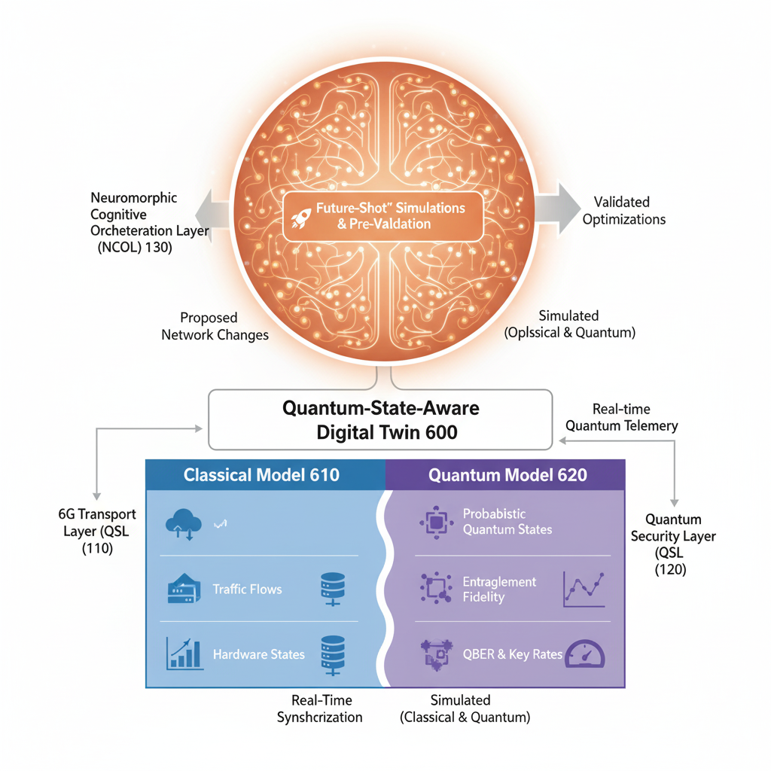

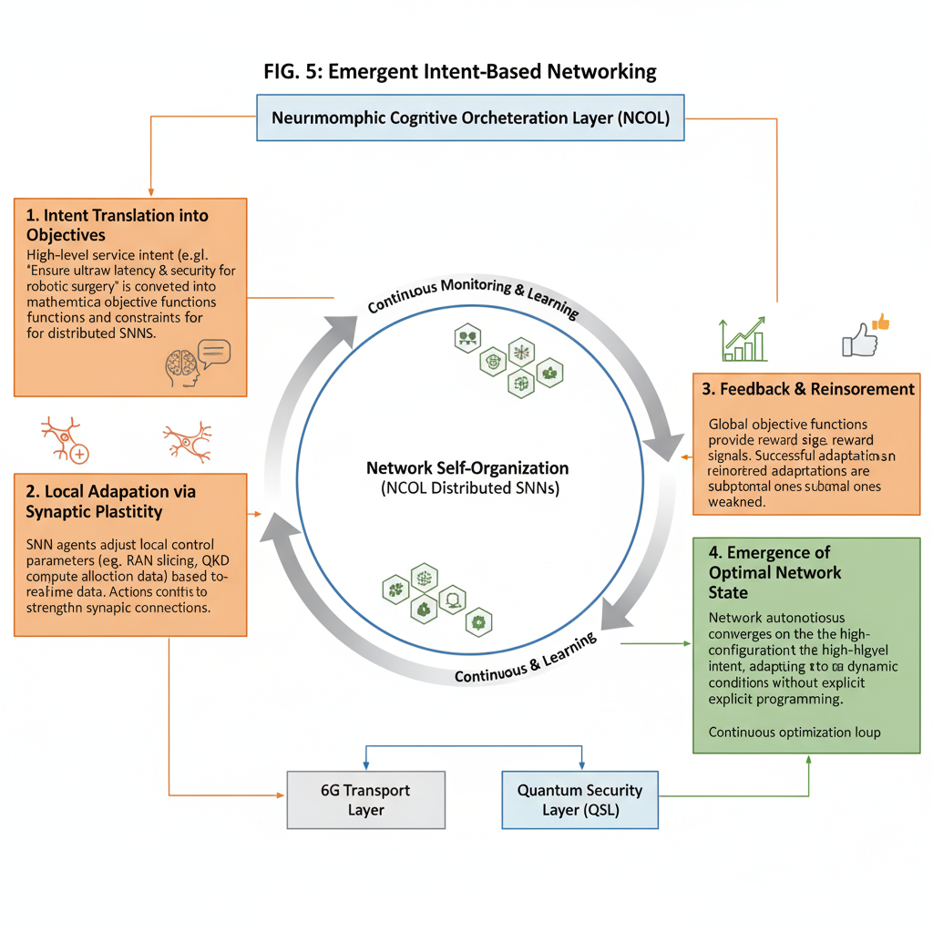

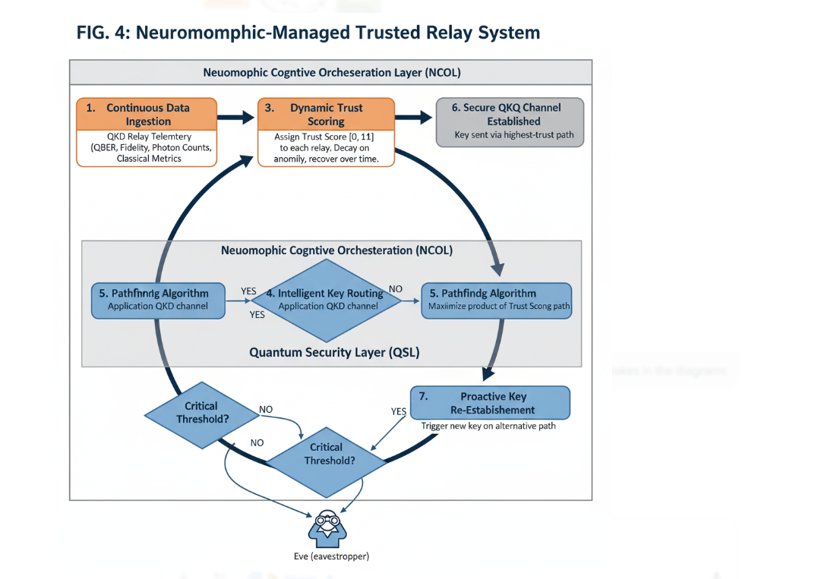

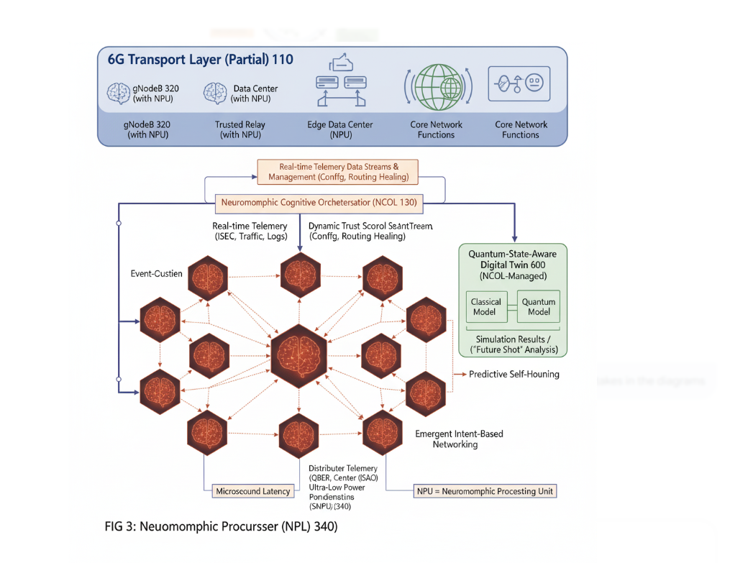

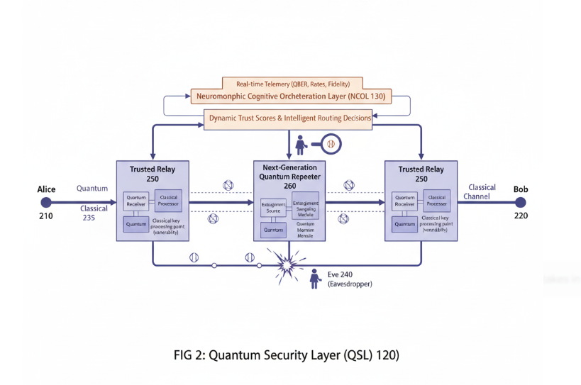

Claims

What is claimed is:
- A telecommunications system, comprising:
a transport layer configured to transmit data packets, said transport layer including a plurality of radio access network nodes and a core network;
a quantum security layer, communicatively coupled to the transport layer, configured to generate and distribute cryptographic keys using quantum mechanical principles; and
a neuromorphic cognitive orchestration layer, comprising a distributed network of neuromorphic processors executing spiking neural networks, configured to receive real-time operational data from the transport layer and the quantum security layer, and to autonomously manage network resources and security policies of said layers based on an analysis of the real-time operational data.
- The system of claim 1, wherein the quantum security layer comprises a plurality of quantum key distribution (QKD) relays, and wherein the neuromorphic cognitive orchestration layer is further configured to:
receive a set of classical and quantum performance metrics from each of the plurality of QKD relays;
calculate, for each QKD relay, a real-time trust score based on a detection of anomalies within the set of performance metrics; and
select a path for distributing a cryptographic key through a subset of the plurality of QKD relays based on maximizing an aggregate trust score along the path.
- The system of claim 2, wherein the quantum performance metrics include at least one of a Quantum Bit Error Rate (QBER) or an entanglement fidelity measurement.
- The system of claim 1, wherein the neuromorphic cognitive orchestration layer is further configured to:
receive a high-level service intent;
translate the high-level service intent into a set of objective functions; and
adapt, via synaptic plasticity in the spiking neural networks, operational parameters of the transport layer and the quantum security layer to optimize for the set of objective functions, whereby a network configuration that fulfills the intent emerges from a self-organizing process.
- The system of claim 1, wherein the transport layer further comprises integrated sensing and communication (ISAC) capabilities configured to generate environmental data, and wherein the neuromorphic cognitive orchestration layer is further configured to:
receive the environmental data and network performance data;
identify a spatio-temporal pattern within the received data that is a precursor to a network fault; and
in response to identifying the pattern, proactively reconfigure a network resource to prevent the network fault before a service degradation occurs.
- The system of claim 1, further comprising a digital twin of the telecommunications system managed by the neuromorphic cognitive orchestration layer, wherein the digital twin comprises:
a classical model representing a state of the transport layer; and
a quantum model representing a probabilistic quantum state of the quantum security layer, said quantum model being continuously updated with real-time measurement data from the quantum security layer.
- The system of claim 6, wherein the neuromorphic cognitive orchestration layer is further configured to execute a simulation of a proposed network configuration change within the digital twin to predict a future classical and quantum state of the system prior to implementing the change on the live telecommunications system.
- A method for managing a communications network, comprising:
generating, via a quantum security layer, a cryptographic key;
transmitting, via a transport layer, data encrypted with the cryptographic key;
monitoring, via a distributed neuromorphic cognitive orchestration layer, a plurality of real-time operational parameters of the quantum security layer and the transport layer; and
autonomously adjusting, via the neuromorphic cognitive orchestration layer, a network resource configuration in response to an event-driven analysis of the operational parameters.
- The method of claim 8, wherein the step of generating a cryptographic key involves a plurality of quantum key distribution (QKD) relays, the method further comprising:
assigning, by the neuromorphic cognitive orchestration layer, a dynamic trust score to each of the QKD relays based on detecting anomalies in their operational parameters; and
routing the generation of the cryptographic key through a path of relays selected to maximize trustworthiness based on the dynamic trust scores.
- The method of claim 8, further comprising:
maintaining, by the neuromorphic cognitive orchestration layer, a hybrid digital twin that models both classical network states and probabilistic quantum network states; and
pre-validating, within the hybrid digital twin, an effect of a potential adjustment to the network resource configuration on both the classical and quantum states before implementing said adjustment.

Works cited
- What's the latest on 6G? Standards, features, use cases and timeline - Thales, accessed on September 27, 2025, https://www.thalesgroup.com/en/worldwide/digital-identity-and-security/magazine/whats-latest-6g-standards-features-use-cases-and
- What To Expect From 6G - SmartViser, accessed on September 27, 2025, https://www.smartviser.com/post/what-to-expect-from-6g
- The path to 6G - European Parliament, accessed on September 27, 2025, https://www.europarl.europa.eu/RegData/etudes/BRIE/2024/757633/EPRS_BRI(2024)757633_EN.pdf
- 6G Development: How Soon Will It Arrive? - PatentPC, accessed on September 27, 2025, https://patentpc.com/blog/6g-development-how-soon-will-it-arrive
- 6G standardization – an overview of timeline and high-level technology principles - Ericsson, accessed on September 27, 2025, https://www.ericsson.com/en/blog/2024/3/6g-standardization-timeline-and-technology-principles
- Next 6G: Key Features, Use Cases, and Challenges of Tomorrow's Wireless Revolution, accessed on September 27, 2025, https://www.e-spincorp.com/next-6g-key-features-use-cases/
- Co-creating a cyber physical world with 6G - Ericsson, accessed on September 27, 2025, https://www.ericsson.com/en/reports-and-papers/white-papers/co-creating-a-cyber-physical-world
- 6G - Wikipedia, accessed on September 27, 2025, https://en.wikipedia.org/wiki/6G
- Exploring the key technologies and applications of 6G wireless communication network - PMC - PubMed Central, accessed on September 27, 2025, https://pmc.ncbi.nlm.nih.gov/articles/PMC12018058/
- Orchestration for 6G: Automating the Networks of Tomorrow | by 6G-Cloud - Medium, accessed on September 27, 2025, https://medium.com/@6g-cloud/orchestration-for-6g-automating-the-networks-of-tomorrow-aedb15d22784
- 6G: The Next Horizon White Paper - Huawei, accessed on September 27, 2025, https://www.huawei.com/en/huaweitech/future-technologies/6g-white-paper
- Quantum-Safe Networks for 6G an Inte- grated Survey on PQC, QKD, and Satel - Scifiniti, accessed on September 27, 2025, https://www.scifiniti.com/uploads/source/articles/computingai-connect/1970/volume2/19700016/article.pdf
- Post Quantum Cryptography - Huawei, accessed on September 27, 2025, https://www.huawei.com/en/trust-center/post-quantum-cryptography
- Post-Quantum Security: Essential Guide to Future-Proofing 6G and Telecom Networks, accessed on September 27, 2025, https://www.6gacademy.com/what-it-is-post-quantum-security/
- What is Quantum Security? - Palo Alto Networks, accessed on September 27, 2025, https://www.paloaltonetworks.com/cyberpedia/what-is-quantum-security
- Cybersecurity Quantum Attack - Identity Management Institute®, accessed on September 27, 2025, https://identitymanagementinstitute.org/cybersecurity-quantum-attack/
- What Is Quantum Computing's Threat to Cybersecurity? - Palo Alto Networks, accessed on September 27, 2025, https://www.paloaltonetworks.com/cyberpedia/what-is-quantum-computings-threat-to-cybersecurity
- Quantum-safe security - Adtran, accessed on September 27, 2025, https://www.adtran.com/en/innovation/quantum-safe-security
- Quantum Key Distribution (QKD) and Quantum Cryptography QC - National Security Agency, accessed on September 27, 2025, https://www.nsa.gov/Cybersecurity/Quantum-Key-Distribution-QKD-and-Quantum-Cryptography-QC/
- Quantum Key Distribution - arXiv, accessed on September 27, 2025, https://arxiv.org/html/2507.23192v1
- Quantum key distribution - Wikipedia, accessed on September 27, 2025, https://en.wikipedia.org/wiki/Quantum_key_distribution
- Should Quantum Key Distribution be Used for Secure Communications? | ANSSI, accessed on September 27, 2025, https://cyber.gouv.fr/en/publications/should-quantum-key-distribution-be-used-secure-communications
- Why making quantum repeaters is hard, accessed on September 27, 2025, https://www.qutube.nl/quantum-internet-14/why-making-quantum-repeaters-is-hard
- Security of quantum key distribution using a simplified trusted relay | Phys. Rev. A, accessed on September 27, 2025, https://link.aps.org/doi/10.1103/PhysRevA.91.012338
- Relaxing Trust Assumptions on Quantum Key Distribution Networks - arXiv, accessed on September 27, 2025, https://arxiv.org/html/2402.13136v2
- AI-Driven 5G Network Slicing: Revolutionizing Enterprise Connectivity - ResearchGate, accessed on September 27, 2025, https://www.researchgate.net/publication/390425844_AI-Driven_5G_Network_Slicing_Revolutionizing_Enterprise_Connectivity
- AT&T U.S. Patents, Patent Applications and Patent Search - Justia ..., accessed on September 27, 2025, https://patents.justia.com/company/att
- WO2017214271A1 - Artificial intelligence-based network advisor - Google Patents, accessed on September 27, 2025, https://patents.google.com/patent/WO2017214271A1/en
- Patents Assigned to T-Mobile USA, Inc, - Justia Patents Search, accessed on September 27, 2025, https://patents.justia.com/assignee/t-mobile-usa-inc
- Neuromorphic vs. Conventional AI: A Data Engineering Tool Review, accessed on September 27, 2025, https://dataengineeracademy.com/blog/neuromorphic-vs-conventional-ai-a-data-engineering-tool-review/
- Neuromorphic computing: The future of AI and beyond - Atos, accessed on September 27, 2025, https://atos.net/en/blog/neuromorphic-computing-the-future-of-ai-and-beyond
- Neuromorphic Computing - an Edgier, Greener AI | Towards Data Science, accessed on September 27, 2025, https://towardsdatascience.com/neuromorphic-computing-an-edgier-greener-ai-3911fab9fe09/
- About 6G technology: 6G Meaning, features, benefits, challenges | Blackview Blog, accessed on September 27, 2025, https://www.blackview.hk/blog/tech-news/6g-technology
- Neuromorphic Computing: Mimicking the Brain Beyond Neural Networks | Onyx, accessed on September 27, 2025, https://www.onyxgs.com/blog/neuromorphic-computing-mimicking-brain-beyond-neural-networks
- What Is Neuromorphic Computing? - IBM, accessed on September 27, 2025, https://www.ibm.com/think/topics/neuromorphic-computing
- How Neuromorphic Systems Improve Anomaly Detection in Networks - Patsnap Eureka, accessed on September 27, 2025, https://eureka.patsnap.com/report-how-neuromorphic-systems-improve-anomaly-detection-in-networks
- Neuromorphic Computing: The New Frontier of AI and Computer Science Inspired by the Human Brain - Assured Systems, accessed on September 27, 2025, https://www.assured-systems.com/neuromorphic-computing-the-new-frontier-of-ai-and-computer-science-inspired-by-the-human-brain/
- Plans & Papers - 6G IA, accessed on September 27, 2025, https://6g-ia.eu/plans-papers/
- 6G explained | Nokia.com, accessed on September 27, 2025, https://www.nokia.com/6g/6g-explained/
- Quantum network - Wikipedia, accessed on September 27, 2025, https://en.wikipedia.org/wiki/Quantum_network
- AT&T Is Buying 95% of Lumen's Quantum Fiber. Will Prices Go Up? - American TV, accessed on September 27, 2025, https://www.americantv.com/att-is-buying-95-percent-of-lumens-quantum-fiber.php
- Neuromorphic Computing - Fraunhofer-Institut für Integrierte Schaltungen IIS, accessed on September 27, 2025, https://www.iis.fraunhofer.de/en/ff/sse/ic-design/neuromorphic-computing.html
- Neuromorphic Computing and Engineering with AI | Intel®, accessed on September 27, 2025, https://www.intel.com/content/www/us/en/research/neuromorphic-computing.html
- AT&T will be “quantum ready” by the year 2025; New fiber network launched in Indiana, accessed on September 27, 2025, https://techblog.comsoc.org/2022/10/07/att-will-be-quantum-ready-by-the-year-2025-but-may-not-be-fully-quantum-secured/
- Quantum Key Distribution (QKD) - Quantum Technology, accessed on September 27, 2025, https://qt.eu/quantum-principles/communication/quantum-key-distribution-qkd
- Quantum cryptography - Wikipedia, accessed on September 27, 2025, https://en.wikipedia.org/wiki/Quantum_cryptography
- Relaxing Trust Assumptions on Quantum Key Distribution Networks - arXiv, accessed on September 27, 2025, https://arxiv.org/html/2402.13136v1
- Quantum Key Distribution (QKD): Securing Secrets with Single Photons - Medium, accessed on September 27, 2025, https://medium.com/quantum-computing-and-cybersecurity/quantum-key-distribution-qkd-securing-secrets-with-single-photons-77904a59a428
- A Neuromorphic Algorithm for Radiation Anomaly Detection, accessed on September 27, 2025, https://impact.ornl.gov/en/publications/a-neuromorphic-algorithm-for-radiation-anomaly-detection
- Quantum Repeaters | Figueroa Research Group - Stony Brook University, accessed on September 27, 2025, https://www.stonybrook.edu/commcms/physics/figueroa-research-group/research/testbed_research/quantum_repeaters.php
- Quantum repeaters use defects in diamond to interconnect quantum systems | MIT News, accessed on September 27, 2025, https://news.mit.edu/2023/quantum-repeaters-use-defects-diamond-interconnect-quantum-systems-0927
- What are quantum repeaters?, accessed on September 27, 2025, https://www.aliroquantum.com/blog/what-are-quantum-repeaters
- Top 10 Companies in Neuromorphic Chip Market in 2024 Shaping Global Industry Trends, accessed on September 27, 2025, https://www.emergenresearch.com/blog/top-10-companies-in-neuromorphic-chip-market
- Neuromorphic computing - Wikipedia, accessed on September 27, 2025, https://en.wikipedia.org/wiki/Neuromorphic_computing
- Explore the 7 Top Neuromorphic Computing Companies & Startups to Watch in 2026, accessed on September 27, 2025, https://www.startus-insights.com/innovators-guide/neuromorphic-computing-companies/
- Enhancing spiking neural networks with hybrid top-down attention - PMC, accessed on September 27, 2025, https://pmc.ncbi.nlm.nih.gov/articles/PMC9443487/
- Is Neuromorphic Computing the Future of AI? - Exoswan Insights, accessed on September 27, 2025, https://exoswan.com/is-neuromorphic-computing-the-future-of-ai
- An example of intent-based 6G network architecture - ResearchGate, accessed on September 27, 2025, https://www.researchgate.net/figure/An-example-of-intent-based-6G-network-architecture_fig2_342972968
- Intent-Based Network Management in 6G Core Networks - IoT Lab, accessed on September 27, 2025, http://iotlab.skku.edu/publications/international-conference/ICTC2022-IBN-6G-Core-Network.pdf
- Toward 6G Native-AI Network: Foundation Model based Cloud-Edge-End Collaboration Framework - arXiv, accessed on September 27, 2025, https://arxiv.org/pdf/2310.17471
- Self-Organising Memristive Networks (SOMNs) - Emergent Mind, accessed on September 27, 2025, https://www.emergentmind.com/topics/self-organising-memristive-networks-somns
- SORN: a self-organizing recurrent neural network - Frontiers, accessed on September 27, 2025, https://www.frontiersin.org/journals/computational-neuroscience/articles/10.3389/neuro.10.023.2009/full
- AI-native networks and the Implications for 6G | Wireless Infrastructure Association, accessed on September 27, 2025, https://wia.org/ai-native-networks-and-the-implications-for-6g/
- Neuromorphic Computing for Real-Time Manufacturing Equipment Decisions - Oxmaint, accessed on September 27, 2025, https://oxmaint.com/blog/post/neuromorphic-computing-for-real-time-manufacturing-equipment-decisions
- Exploring Spiking Neural Networks for Prediction of Traffic Congestion in Networks- on-Chip - Pure - Ulster University's Research Portal, accessed on September 27, 2025, https://pure.ulster.ac.uk/files/78532266/ISCAS_Paper_v3.1.pdf
- Exploring Spiking Neural Networks for Prediction of Traffic Congestion in Networks-on-Chip | Request PDF - ResearchGate, accessed on September 27, 2025, https://www.researchgate.net/publication/349293689_Exploring_Spiking_Neural_Networks_for_Prediction_of_Traffic_Congestion_in_Networks-on-Chip
- AI-Driven Network Slicing in 5G and Beyond: Unlocking Intelligent Connectivity - Byanat, accessed on September 27, 2025, https://www.byanat.ai/blog/ai-driven-network-slicing-in-5g-and-beyond-unlocking-intelligent-connectivity
- AI in network operations: How do you build trust in a self-healing network? - STL Partners, accessed on September 27, 2025, https://stlpartners.com/articles/network-innovation/ai-in-network-operations/
- Digital Twin Network-Based 6G Self-Evolution - MDPI, accessed on September 27, 2025, https://www.mdpi.com/1424-8220/25/11/3543
- Neuromorphic quantum computing | Phys. Rev. E - Physical Review Link Manager, accessed on September 27, 2025, https://link.aps.org/doi/10.1103/PhysRevE.106.045311
- Neuromorphic QC (NQC) - Quantum Computing Modalities, accessed on September 27, 2025, https://postquantum.com/quantum-modalities/neuromorphic-quantum-computing/
- Quantum neuromorphic computing - OSTI, accessed on September 27, 2025, https://www.osti.gov/servlets/purl/1852977
- AT&T Intellectual Property | AT&T Innovation, accessed on September 27, 2025, https://about.att.com/innovation/ip
- Patents – Sales & Licensing | AT&T Intellectual Property, accessed on September 27, 2025, https://about.att.com/innovation/ip/patents
- AT&T hopes quantum networking will amplify the power of quantum computing - CNET, accessed on September 27, 2025, https://www.cnet.com/tech/computing/att-hopes-quantum-networking-will-amplify-the-power-of-quantum-computing/
- Huawei's Quantum Encryption Patents: Securing Future Data ..., accessed on September 27, 2025, https://patentpc.com/blog/huaweis-quantum-encryption-patents-securing-future-data-transfers
- Charting the path to 6G | Nokia.com, accessed on September 27, 2025, https://www.nokia.com/6g/
- 6G spectrum - future mobile life beyond 2030 - Ericsson, accessed on September 27, 2025, https://www.ericsson.com/en/reports-and-papers/white-papers/6g-spectrum-enabling-the-future-mobile-life-beyond-2030

Abstract: A system and method for a self-managing, quantum-secured sixth-generation (6G) communications network is disclosed. The system comprises a tri-layered architecture featuring a 6G Transport Layer for high-throughput data transmission, a Quantum Security Layer (QSL) for providing information-theoretic security, and a Neuromorphic Cognitive Orchestration Layer (NCOL) for autonomous network management. The QSL utilizes a hybrid of Post-Quantum Cryptography (PQC) and Quantum Key Distribution (QKD) to secure network communications against both classical and quantum threats. The NCOL, implemented via a distributed network of neuromorphic co-processors running Spiking Neural Networks (SNNs), provides real-time, low-latency, and energy-efficient control over both the transport and security layers. Key inventive steps include a method for neuromorphic management of QKD trusted relays, wherein the NCOL dynamically assesses relay trustworthiness to route quantum keys along the most secure paths, thereby mitigating critical vulnerabilities in prior art. The invention further includes a system for emergent intent-based networking, where the network self-organizes to fulfill high-level service objectives, and a method for predictive self-healing based on microsecond-level anomaly detection. A quantum-state-aware digital twin, managed by the NCOL, enables high-fidelity simulation and pre-validation of network optimizations, including the probabilistic behavior of the quantum layer, facilitating true network self-evolution.

